**Milestone Two Document**

|  |  |  |  |
| --- | --- | --- | --- |
| **Group** | Neon Nova | Date | December 5th, 2024 |

|  |  |
| --- | --- |
| **Project Title** | The VR Vacation |
| **Milestone** | 2 |
| **Professor** | Dr. Muhammad Asaduzzaman |
| **Contributors** | Htoo Myat Soe Paing  John Ekemini  Aaron Rangira  Angela Ilievska |



**1. Sketches of the proposed software layout**

**a) Main Screen – Home Page**

The main screen will serve as a navigation page for the user. Here they will be able to quickly navigate to the different pages, such as: products, booking, about, help, contact, return and their cart, which they will then be able to receive more information about their inquiries.

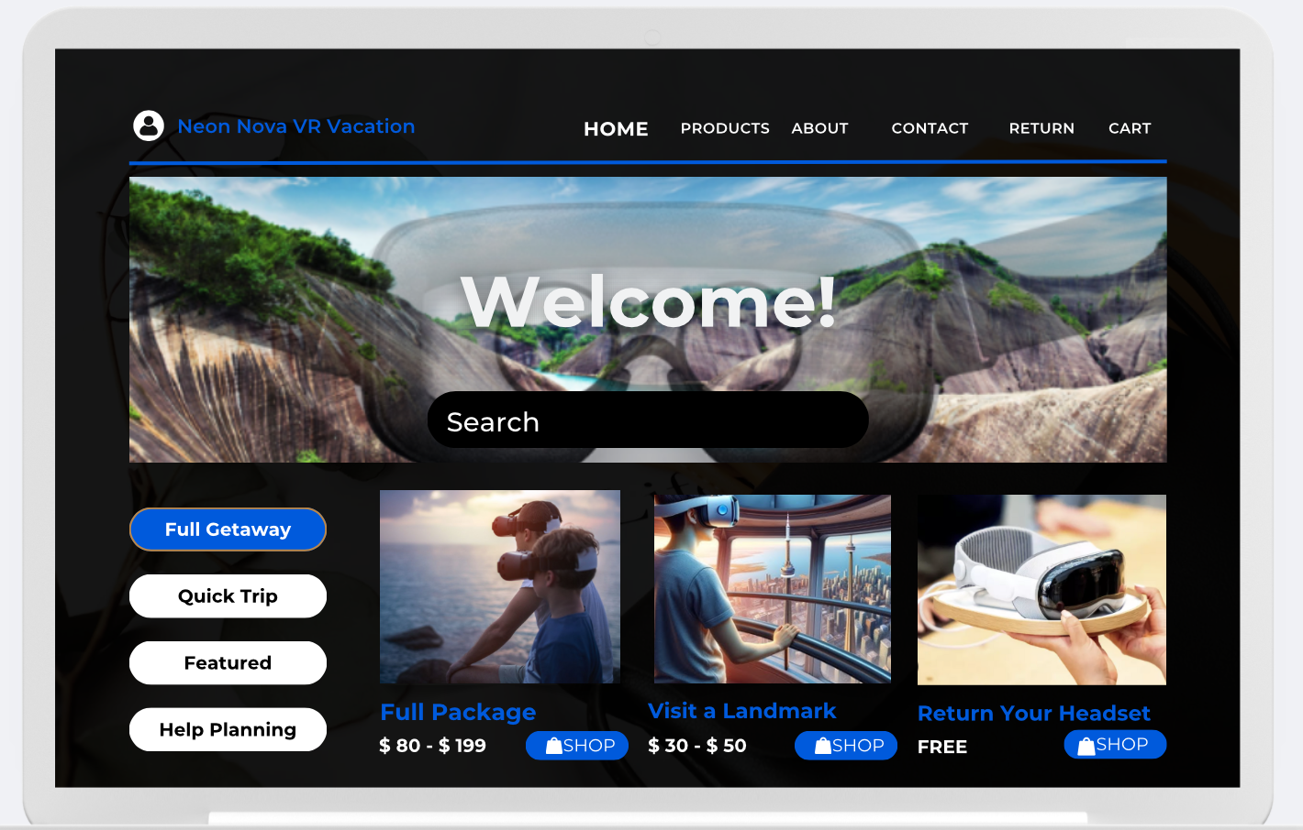

**b) Login Screen**

This page is the log-in screen where users can create an account or sign in to their existing account. The user is only required to provide an email address and password to sign up, which will then be connected to their account where they can make faster purchases, view order history, and receive help more efficiently when needed.

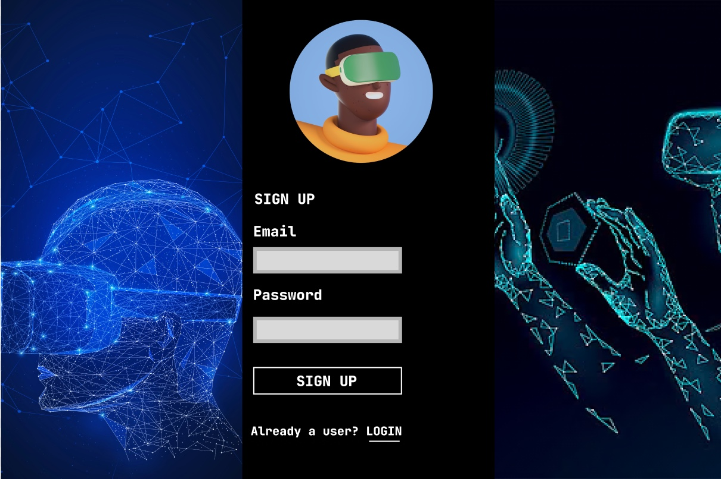

**c) VR Vacation Package Selection Screen**

This is the screen responsible for showcasing the different travel destinations for the user. Here it simply shows an image for the different locations the user can visit, and once the user finds one that peaks their interest they can select “see more” button to be brought to that specific destinations’ page to get even more information.

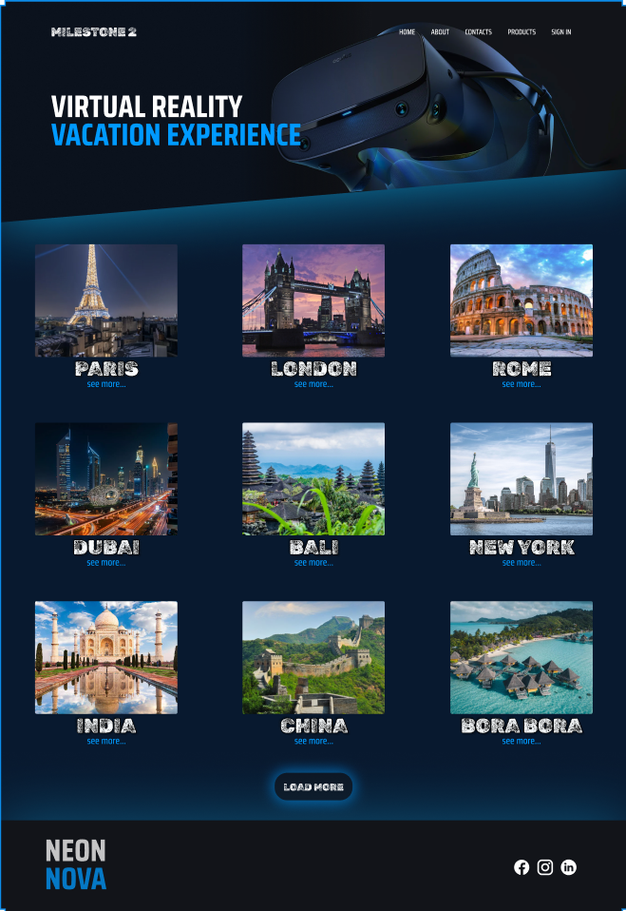

**d) Search Filters Screen**

This is the screen where the user can find their dream location, for their dream budget, more effectively. The user can use the search filters to filter by, location, rental period, VR model, VR type, number of people, price range, square footage they want their vacation to cover, newer or older spots, and by specific landmarks. This page allows the user to not waste any time in finding their ideal vacation that fits their necessary criteria.

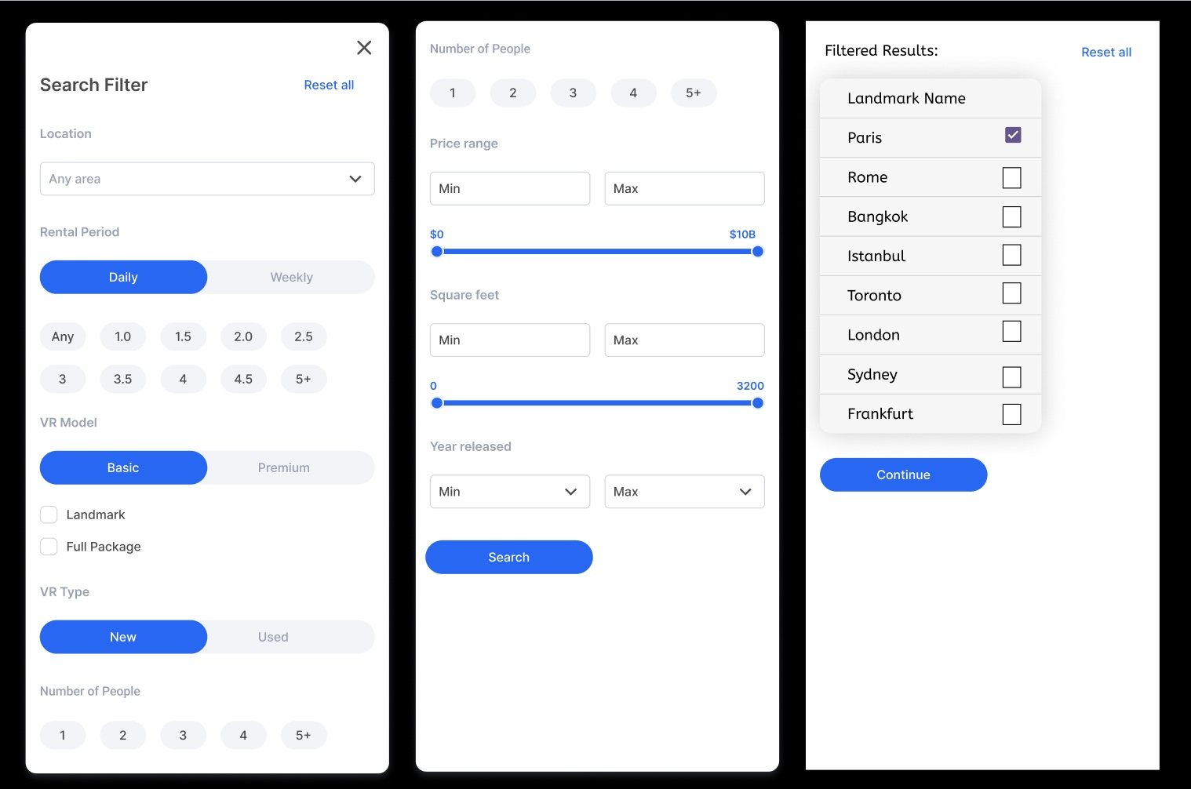

**e) Checkout Screen**

The checkout screen will be responsible for handling all the users' payments and final reviews. Here the user will be able to see exactly what they are purchasing for what price, input all their delivery information, provide payment in many ways and receive an exact summary of their purchase before finalizing. This page is structured in a way so that all the necessary information for the user is captured in one location, minimizing confusion and helping processing times.

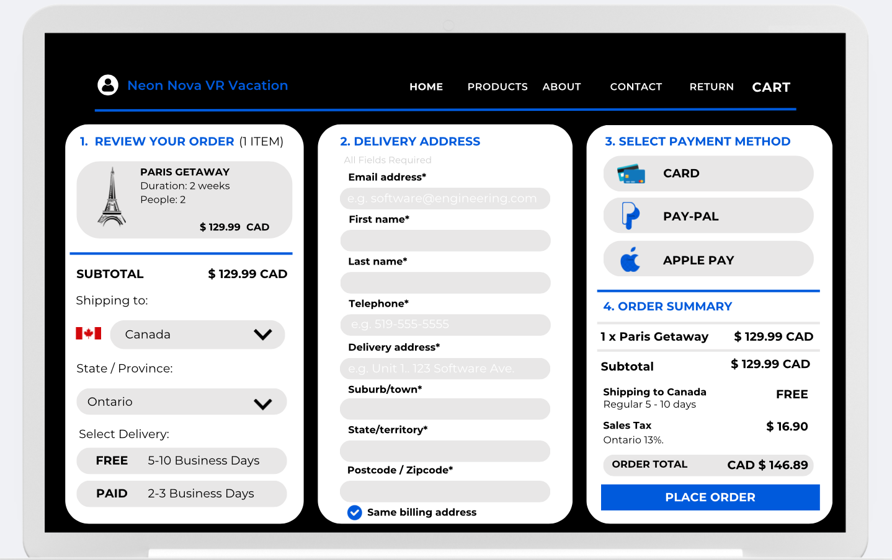

**f) Confirmation of Purchase Screen**

This is the page the user will encounter once their purchase is complete. This page will reassure the user that their order has been received and is currently undergoing the fulfillment process. It will also allow the user the sign up for emails if they haven’t already which can increase our customer engagement rates, they can also navigate back to the homepage quickly for more shopping, and visit the page for returns so they can plan for what to expect by the end of their virtual vacation.

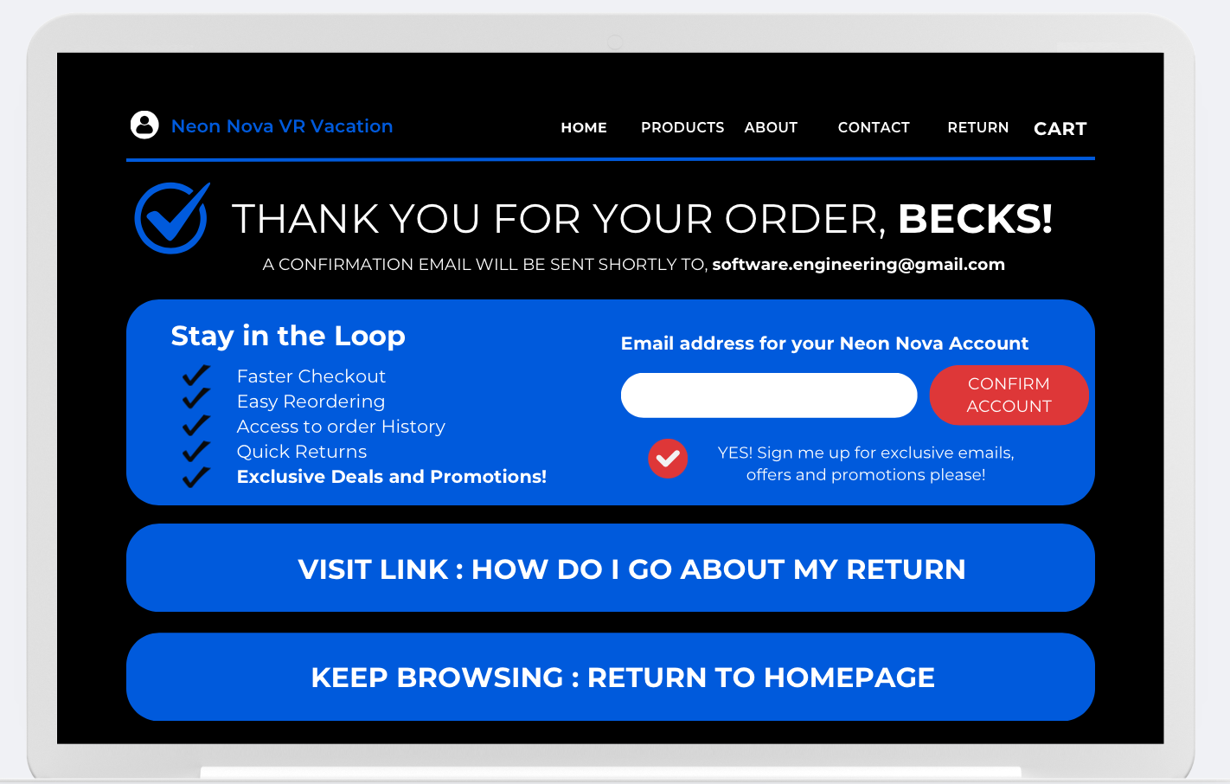

**g) Return Screen (The customer has already completed their purchase, enjoyed their virtual vacation, and is now looking to return the headset)**

This is the screen created to handle all customer returns, and inquiries related to those returns. Here the customer is provided with easy step-by-step instructions on how to properly handle the return of their rented equipment. There are also links to a “missing return label” page where if for any reason the customer wasn’t provided with a free return label or misplaced theirs, by providing some simple information, they can be provided with another one that they can print. There is another link to a “missing/broken part” page which instructs the customer what will happen if they were given a missing or broken part, or if they cause damage to any equipment. Finally, there is a “contact us” button where the customer can receive help for any issues this page wasn’t able to solve.

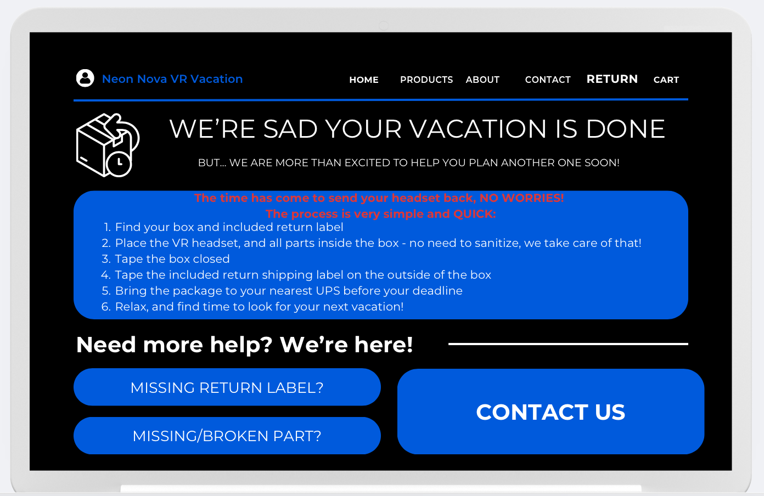

**h) Screen Once a Destination is Selected**

This is the page the customer will see once they click the “see more” button on the products page for a specific destination. Here they will be provided with a picture of their vacation package, the price and duration, as well as a description of the place they have chosen to visit. From this page they can place locations in their cart, to then be able to process their order and get their virtual vacation delivered.

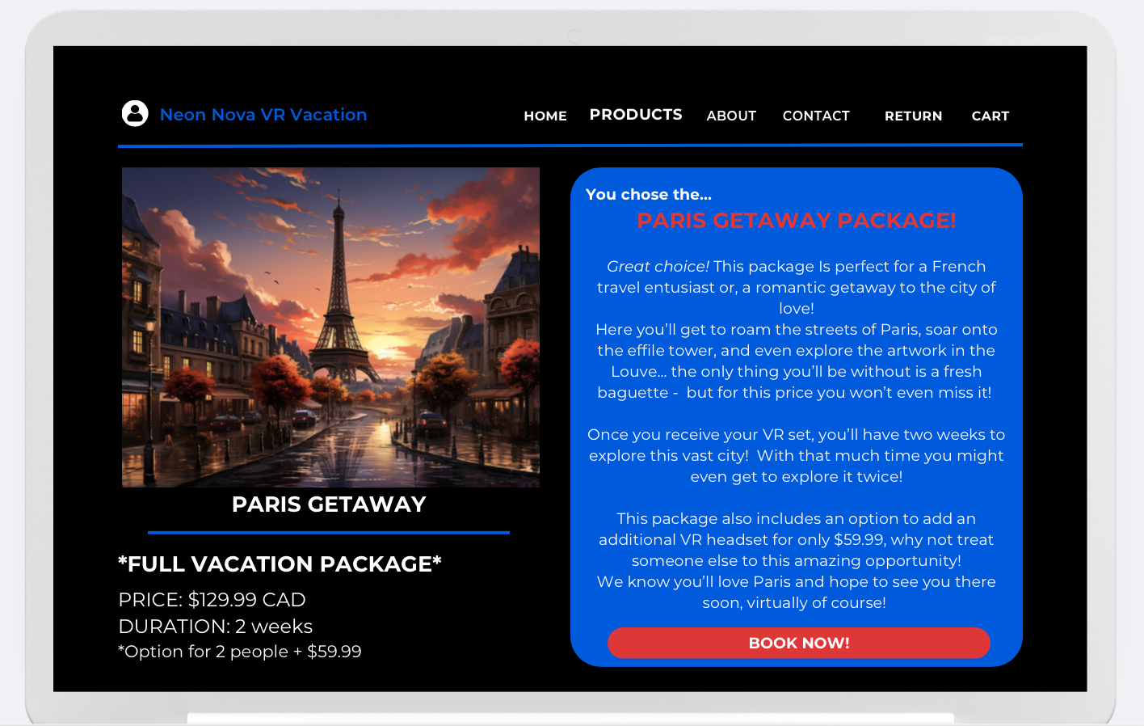

**I) Contact Page**

This is the page that the customer can visit to contact us about any inquiries, comments, complaints, and complements they may have. This page can handle all the customers' needs, as it is a page to give them a direct communication channel with us, the developers, as well as the customer service team. It also provides them with a ‘quick message’ section, where they do not have to visit any other emailing site, they can contact us directly off our site and receive a reply directly to their email.

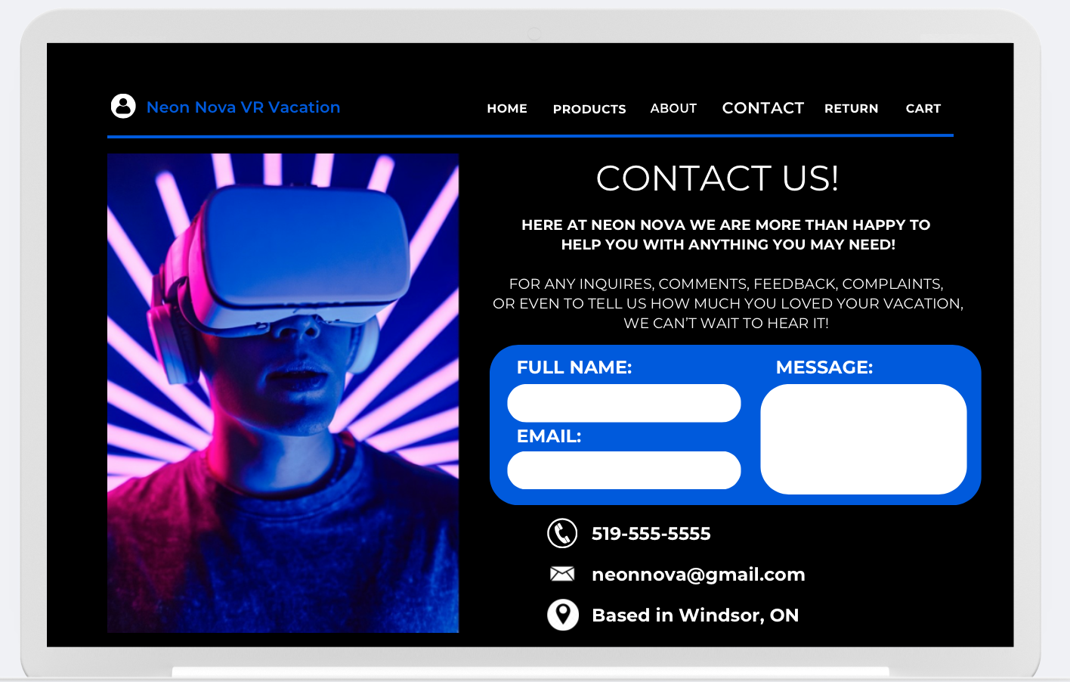

**2) Test Case Description Related to Each of the Five Use Cases**

**Down below are the test cases related to each of our five use cases provided in milestone 1. Both non-functional and functional requirements are considered for each use case, and 3 test cases are provided for each use case.**

**Use Case #1: VR Headset Delivery**

**Test Case 1: Valid Order Submission**  
*INPUT:*  
1. User’s mailing address  
2. Destination selection  
3. Rental duration  
4. User’s payment information  
*TEST CONDITIONS:*  
1. The address is valid and formatted correctly  
2. The VR headset model selected must be in stock.  
3. Rental duration is within the permissible range  
4. Card type is supported and valid   
*OUTPUT:*  
Confirmation of order placement, estimated delivery date, and set-up instructions all sent to given customer email.

**Test Case 2: Missing or Incorrect Address**  
*INPUT:*  
1. Invalid or incomplete mailing address  
2. Valid VR headset model  
3. Rental duration  
4. User’s payment information  
*TEST CONDITIONS:*  
1. System checks if the address is invalid (e.g., missing postal code)  
2. System detects incomplete fields in the address form  
*OUTPUT:*  
Error message requesting the user to input a valid address before proceeding with the order

**Test Case 3: Shipment Tracking**  
*INPUT:*  
1. Order ID  
2. User’s login credentials   
*TEST CONDITIONS:*  
1. Valid order ID and system connectivity to the shipping company’s API  
2. Invalid order ID (edge case)   
*OUTPUT:*  
Tracking details (valid ID) or error message indicating “Order ID not found.”

**Use Case #2: Choosing a Destination**

**Test Case 1: Valid Destination Selection**  
*INPUT:*  
1. User’s destination choice   
*TEST CONDITIONS:*  
1. The destination is available in the system database   
2. The system responds within a defined performance time (e.g., <3 seconds)  
*OUTPUT:*  
Preview of the selected destination, VR tour details (duration, attractions)

**Test Case 2: Inaccessible Destination**  
*INPUT:*  
1. A destination that is currently unavailable   
*TEST CONDITIONS:*  
1. The system checks the availability of the destination  
2. If unavailable, alternative suggestions are offered   
*OUTPUT:*  
Error message with options for alternate destinations or a waitlist

**Test Case 3: Invalid Input**  
*INPUT:*  
1. Malformed or empty destination query  
*TEST CONDITIONS:*  
1. Input field left blank or filled with random characters   
2. The system validates input against known destination data  
*OUTPUT:*  
*Error message requesting the user to provide a valid destination name.*

**Use Case #3: Headset Return**

**Test Case 1: Successful Return**  
*INPUT:*  
1. VR headset  
2. Valid return shipping label   
*TEST CONDITIONS:*  
1. The return shipping label is valid and scannable   
2. The package is delivered to the warehouse without damages   
*OUTPUT:*  
Confirmation email indicating successful return and completion of the rental.

**Test Case 2: Damaged Components**  
*INPUT:*  
1. VR headset with visible damage   
*TEST CONDITIONS:*  
1. The warehouse inspection process detects hardware or component damage   
2. The damage falls within or exceeds the user’s liability terms  
*OUTPUT:*  
Notification of damage repair fees sent to the user.

**Test Case 3: Invalid Return Shipping Label**  
*INPUT:*  
1. Damaged or missing return label  
*TEST CONDITIONS:*  
1. The system fails to validate the shipping label   
2. User contacts customer support for a replacement label  
*OUTPUT:*  
New return shipping label is issued with an updated timeline for the return.

**Use Case #4: Customer Support**

**Test Case 1: Quick Query Resolution**  
*INPUT:*  
1. Support request via live chat (e.g., technical issues)  
*TEST CONDITIONS:*  
1. The system identifies the issue using diagnostic tools  
2. The system resolves the issue without escalation  
*OUTPUT:*  
Resolution provided to the user within an acceptable timeframe (e.g., <5 minutes)

**Test Case 2: Escalation to Advanced Support**  
*INPUT:*  
1. Complex issue that the first-tier agent cannot resolve  
*TEST CONDITIONS:*  
1. The initial agent forwards the request to a higher-tier support team  
2. Clear communication is maintained throughout the process  
*OUTPUT:*  
The issue is resolved with advanced support, and the user is informed of all steps taken.

**Test Case 3: Support Request Timeout**  
*INPUT:*  
1. Delayed system response or no response to the support query  
*TEST CONDITIONS:*  
1. The system takes too long to respond due to server downtime  
2. The query exceeds a defined timeout period (e.g., 15 minutes)  
*OUTPUT:*  
Notification to the user about the delay and assurance of a follow-up response.

**Use Case #5: Booking and Managing Virtual Tours**

**Test Case 1: Successful Booking**  
*INPUT:*  
1. User’s login credentials   
2. Destination choice   
3. Payment details   
*TEST CONDITIONS:*  
1. Valid login credentials and payment information   
2. Destination is available, and the system confirms the tour   
*OUTPUT:*  
Confirmation of booking, details of the tour, and payment receipt sent through to provided email.

**Test Case 2: Payment Failure**  
*INPUT:*  
1. Incorrect payment information (e.g., expired card)  
*TEST CONDITIONS:*  
1. The payment system attempts to process the transaction  
2. Payment fails due to insufficient funds or invalid card details   
*OUTPUT:*  
Error message with instructions to update payment information.

**Test Case 3: Modifying a Booking**  
*INPUT:*  
1. User requests to change destination or tour dates   
*TEST CONDITIONS:*  
1. Modification request falls within the permissible timeframe (e.g., 48 hours before the tour)  
2. System checks for conflicts with existing bookings.  
*OUTPUT:*  
Updated booking details or a notification about conflicts with options for resolution.